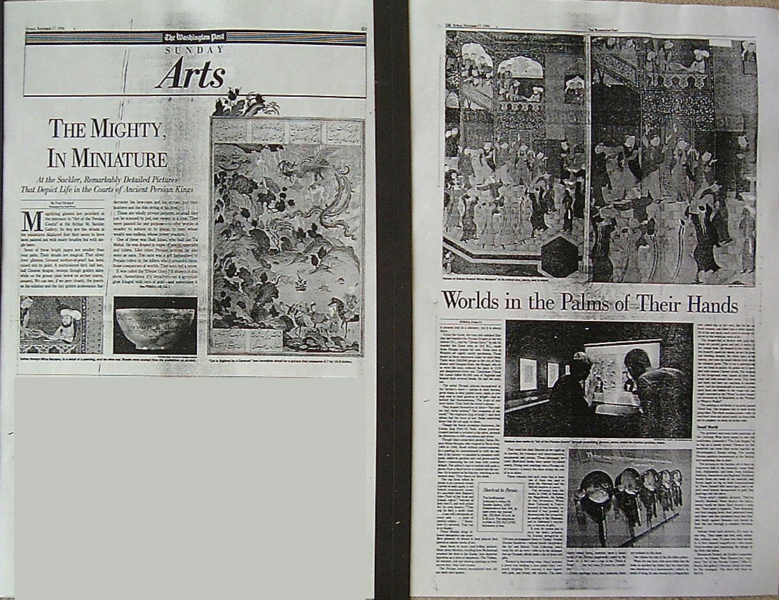

Washington Post

THE MIGHTY, IN MINIATURE

At the Sackler, Remarkably Detailed Pictures That Depict Life in the Courts of Ancient Persian Kings
By Paul Richard
Washington Post Staff Writer
Sunday, November 17, 1996 ; Page G01
Magnifying glasses are provided at the entrance to "Art of the Persian Courts" at the Arthur M. Sackler Gallery. So tiny are the details in the miniatures displayed that they seem to have been painted not with bushy brushes but with single hairs.
Some of these bright pages are smaller than your palm. Their details are magical. That silver river glistens. Ground mother-of-pearl has been mixed into its paint. A multicolored bird, half hen, half Chinese dragon, swoops though golden skies while on the grassy plain below an archer stares, amazed. We can see, if we peer closely, the jewels on his scimitar and the tiny golden arabesques that decorate his bow-case and his arrows and their feathers and the thin string of his bow.
These are wholly private pictures, so small they can be scanned by just one viewer at a time. They were painted for one purpose -- to offer worlds of wonder to sultans or to khans, to men whose wealth was endless, whose power absolute.
One of these was Shah Jahan, who built the Taj Mahal. He was draped in ropes of pearls, emeralds and rubies. Like other Persian princes, he also wore an aura. The aura was a gift bequeathed to Persian rulers by the killers who'd preceded them, those conquerors of worlds. That aura had a name.
It was called the "Divine Glory." It shivers in this show. Sometimes it's depicted -- as a greenish glow fringed with rays of gold -- and sometimes it is present only as a shimmer, but it is always there.
Cyrus the Great, the man who subdued Babylon and founded the Persian Empire in the 6th century B.C., had the "Divine Glory." So did Alexander the Great who, in 333 B.C., made those Persian realms his own. Halos seen in Western art signify saintly gentleness. Those shown in these miniatures imply no such thing. There were 500,000 people in the city of Neyshabur until Genghis Khan, the Mongol, who also wore the aura, reduced the place in 1219 and slaughtered every one. Tamerlane (Timur the Lame) killed 90,000 men of Baghdad and heaped their severed heads. He had the aura, too.
The softer Persian princes encountered in the Sackler's show -- sultans in their harems, great khans in their golden tents, shahs at evening ease in their gardens of delight -- had inherited that fearsomeness. The fruits of war were theirs. They lived the victor's dream.
They draped themselves in titles -- "the master that curbs nations," "the ornament of the world," "the mightiest king of kings" -- and their whims had the force of law. Rules restricting lesser folk did not apply to them.
Though the Koran promotes chasteness, the Iranian king Fath-Ali Shah, whose jewel-encrusted portrait is included in the show, devoted his attentions to 800 concubines and wives.
Though Islam proscribes alcohol, Sultan Hosayn Mirza Bayqara, who reigned in Herat from 1469 to 1506, drank without embarrassment. In a painting he commissioned in 1481 we see him in his harem -- a paradise in miniature with pools, walled-in gardens and cool green-marble floors -- consuming his red wine with evident delight. The sultan's cape is worked with gold; a plume from a black heron is tucked into his turban. He is seated on his balcony, watching as his women sway. They dance for him alone.
The cup from which he drinks is no common vessel. Carved of solid agate, a yellowish translucent stone, it's inscribed with Hosayn's titles ("lord of the Arab and Iranian rulers," "warrior of holy wars"), and with praise for its own beauty: "This cup [is like] a sunlit cloud . . . a sea with whirlpools on every side . . . a mine of molten rubies . . ." Somehow it's survived. That cup is on display.
These Muslim kings allowed themselves one more illicit pleasure: At leisure in their palaces they peered at minute works of art.
Islam tends to scorn story-telling pictures. Many pious Muslims, recalling how Mohammad smashed the idols in the Kaaba, view depictive figuration as a form of blasphemy. The Taliban, for instance, still see slashing paintings as their sacred duty. Only God creates.
The Persian princes encountered here did not share such qualms.
They went into their libraries as we might go to movies, for romance and entertainment, amazement and escape. These fabulously detailed illustrated books were never circulated widely. Poring over paintings was a Persian ruler's luxury -- a luxury this show invites the rest of us to share.
These volumes had such value that at least one of them was used to keep the Ottoman and the Safavid empires at peace.
The occasion was the death, in 1566, of Suleiman the Magnificent, the Sultan of the Ottomans. When Shah Tahmasb in Tabriz learned of his demise, he decided it was prudent to demonstrate his sympathy by sending to the Ottomans, and to Suleiman's successor, a caravan of gifts.
It took 34 camels just to carry the shah's presents. An Iranian delegation of 720 men accompanied them to Turkey. Scholar Abolala Soudavar -- whose family established the Art and History Trust Collection, which owns the art on view -- tells us in his catalogue that an Ottoman official made a list of those rich gifts.
"Ranked in descending value, [they] included a jewel box holding a pear-sized ruby, two pearls weighing [2 1/2 ounces], a tent topped with gold, and twenty silk carpets. The most highly valued items, however, were a manuscript of the [Koran] (supposedly copied by the Imam Ali, d. 661) and a copy of the ["Book of Kings"] . . . that had taken 20 years for completion."
Three paintings from that wondrous book are included in this show.
One relates the tale of Zal, the albino prince.
When Zal was born with snow-white hair his looks so spooked his father that the royal baby was abandoned on a mountainside -- where, instead of dying, he was rescued by a dragon-bird who raised him as her own. She fed him on fresh venison, and killed him a white leopard. All of this and much, much more is minutely depicted in this wondrous work of art.
The dragon-bird is flecked with gold. Her wings are purple, green and red. A deer is in her orange beak, the leopard in her talons. All the leopard's spots are shown, as are his claws and bleeding wounds, the white hairs on his tummy, and even the small follicles from which his whiskers grow. This is not a painting that one can drink in quickly. Its golden sky is sprinkled with curious Chinese clouds. The donkeys in the foreground wear tassels on their trappings and bells around their necks. Tiny birds and bears and deer are watching in astonishment. And the mountainside is haunted: a dozen spirit faces are hidden in the crags -- as cunningly concealed as the "Ninas" in some theatrical caricature by Al Hirschfeld, or the "Waldos" in "Where's Waldo?".
The painting is attributed to an artist named Abdol-Aziz. One imagines him at work slowly going blind. The whole amazing scene -- with its wind-bent trees and spiral clouds, its brass bells and its poppies -- is about six inches wide.
Small World
The greatest and most noble paintings of the Christian West were meant to awe the multitudes. Leonardo's "The Last Supper" is as big as a movie screen. Viewers by the hundreds can crane their necks together at Michelangelo's Sistine ceiling. The careful Persian painters encountered at the Sackler had something else in mind.
The pictures at the Sackler, all of them on long-term loan to the museum, come from Iran, Afghanistan, and India, from Esfahan, Bukhara, Samarkand and Baghdad. Exhibited beside them are seals of cut emerald, and Koran pages as big as beds (commissioned by Timur himself 600 years ago), and a superb steel helmet damascened in gold. But paintings rule the show.
These aren't realistic pictures. They're heavily idealized. None depicts the dusty, messy world we know. Each invents a new one. Their spirit is hypnotic. Their blossoms and their singing birds, their patterned tents and tiles -- and the calculated ways that they play depth against flatness -- are meant to lead the eye through a complex rhythmic dance.
Sultans loved such pictures. It's easy to see why. They make one feel, well, sultanlike, solitary, vast. To peer into their worlds is to feel oneself magnificent -- like some cloud-swathed god examining the doings of the little folk below.
Massumeh Farhad, the Sackler's associate curator for Islamic Near Eastern art, organized "Art of the Persian Courts." Milo C. Beach, the gallery's director, wrote an essay for the catalogue. The show will close on April 6.

