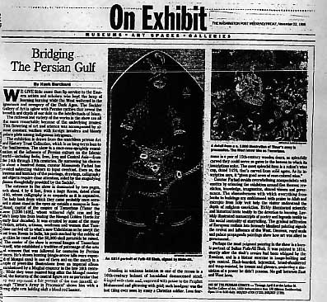Washington Post

Bridging The Persian Gulf
By Hank Burchard
Column: ON EXHIBIT
Friday, November 22, 1996 ; Page N55
WE GIVE little more than lip service to the Eastern artists and scholars who kept the lamp of learning burning while the West weltered in the ignorance and savagery of the Dark Ages. The Sackler Gallery of Art is aglow with Persian rarities that reveal the breadth and depth of our debt to the intellectuals of Islam.
The richness and variety of the works in the show are all the more remarkable because of the underlying ironies: This flowering of art and science was accompanied by almost constant warfare with foreign invaders and bloody palace plots among indigenous intriguers.
The exhibition is drawn from the matchless private Art and History Trust Collection, which is on long-term loan to the Smithsonian. The show is a once-over-sprightly examination of the influence of Persian culture on the Islamic world -- including India, Iran, Iraq and Central Asia -- from the 14th through 19th centuries. By narrowing his choices to about a hundred items, curator Massumeh Farhad has avoided subjecting visitors to input overload. Even so, the fineness and intricacy of the paintings, drawings, calligraphy and objects require close attention, aided by the magnifying glasses thoughtfully provided by the Sackler.
The entrance to the show is dominated by two pages, each about 4 by 6 feet, from a huge Koran, dated about 1400, whose calligraphy is as exquisite as it is expansive. The holy book from which they came probably once occupied a stone stand in the open air outside a mosque in Samarkand, capital of the empire of Tamerlane (Timur the Lame [1336-1405], whose withered right arm and leg didn't keep him from leading the Mongol Golden Horde for nearly four decades). It was created by some of the many scholars, artists, artisans, workmen and women that Tamerlane carried off to what's now Uzbekistan as he swept the East from Russia to India, his path marked by the rubble of the cities he razed and the 50,000-skull pyramids he raised.
The center of the show is several images of Tamerlane himself, who established a tradition of patronage of the arts and sciences that was followed for centuries by Persian princes. He's shown hunting (single-arrow kills were expected of Mongol men) in one of them and on the march in a couple of jewel-like illustrations from an imperial album commissioned by a Mughal emperor in the late 16th century. While they were painted long after the Mongol master died, the features of the central figure are so particular that they may represent a fair portrait of the man himself, although "Timur's Army in Procession" shows him with a strong right arm holding aloft a blood-red banner.
Standing in ominous isolation in one of the rooms is a 16th-century helmet of burnished damascened steel, fringed with chain mail, engraved with praise to the Prophet Mohammed and glittering with gold; such headgear was the last thing ever seen by many a Christian soldier. Less fearsome is a pair of 15th-century wooden doors, so splendidly carved they could serve as gates to the heaven to which its inscriptions refer. The most splendid item is a sultan's wine cup, dated 1470, that's carved from solid agate. As its inscription says, it "gives good news of rose-colored wine."
Curator Farhad avoids overwhelming nonspecialists with exotica by orienting the exhibition around five themes: revelation, knowledge, imagination, shared visions and governance. The obsessiveness with which everything from books to buildings are emblazoned with praise to Allah and excerpts from holy writ help the visitor understand the depth of religious conviction. Richly illuminated scientific and historical texts testify to the devotion to learning. Lavishly illustrated manuscripts of poetry and legends testify to the social centrality of storytelling. The gradual infiltration of European realism into formerly idealized painting signals the revival and influence of the West. Decrees, royal seals and palace propaganda paintings show how art was allied to government.
Perhaps the most poignant painting in the show is a heroic portrait of Sultan Fath-Ali Shah. It was painted in 1814, shortly after the shah's armies had been whipped by the Russians, and is a blatant exercise in image-building and spin control. Black-bearded, bejeweled, broad-shouldered and wasp-waisted, he towers and glowers, projecting a simulation of a power he didn't possess. No gulf between East and West here.
ART OF THE PERSIAN COURTS -- Through April 6 at the Arthur M. Sackler Gallery of Art, 1050 Independence Ave. SW (Metro: Smithsonian). Open 10 to 5:30 daily. 202/357-2700 (TDD: 202/357-1729).

